**PROJECT PLANNING: -**

1. 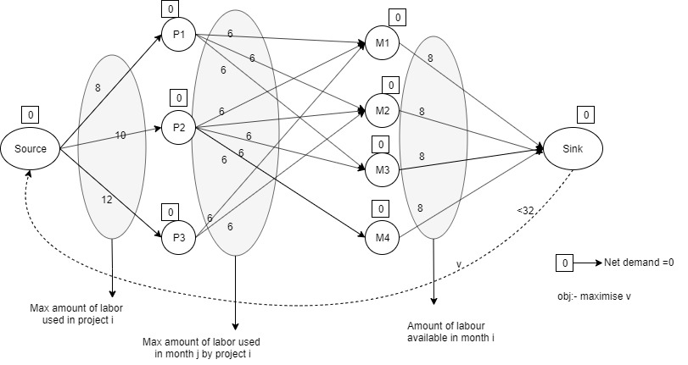The network diagram is shown below:-
2. Pyomo formulation is attached.
3. The optimal solution and interpretation are :-

* The amount of man month used in project 1 is 8 , project 2 is 10, project 3 is 12.
* For the first month, 2 people worked for Project1 and 6 for project 3 ,therefore in total 8 people worked in month1
* For the second month,2 people worked for project 2 and 6 people for project3, therefore in total 8 people worked in month2.
* For the third month,6 people worked for project 1 and 2 people for project2, therefore in total 8 people worked in month3.
* For the fourth month,6 people worked for project 2, therefore in total 6 people worked in month4.
* Therefore total 30 labors used to complete all the 3 projects in 4 months. In other words the maximized man month (objective function) to complete all projects in 30

**STORE OPENING: -**

1. 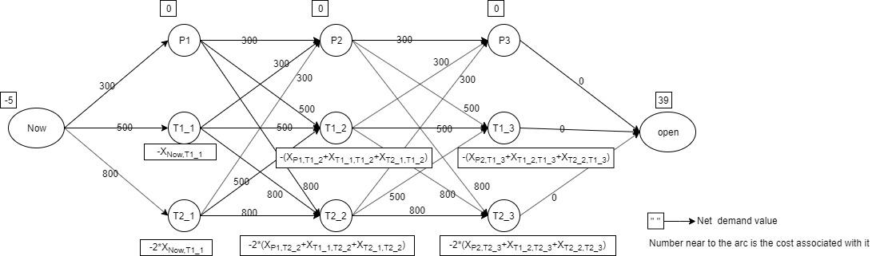The network diagram is shown below:-
2. Pyomo formulation is attached.
3. The optimal solution and interpretation are:-

* In the first week, Number of employee assigned to preparation is 2, to train one is 1.11, to train two is 1.88 ( the output is real because it is an LP problem and it doesn’t signifies the proper meaning of having decimal number)
* In the second week, additional 3 people are added to preparation(total 5) from training 2 new employee session of previous week. Also 4.88 people were send to train 2 people from the previous session of training 1 new employee (2.22) and training 2 new employee (2.66).
*  In the third week, 10 people were send to preparation from the previous weeks train 2 session. Moreover in total 9.66 people were send to the preparation from last week preparation session(5people) and last week train 2 session (4.66 people)
* At last while opening there are 39 employees- 10 in preparation and 29 in training 2 new employee session.
* The (minimized) cost incurred for the management (objective function) to meet all requirement is $18811.11.